Here is an work flow for a script  
  
Go to https:<https://lodges.glflamason.org/public/Lodge-Search>  
Select search by lodge by Zip Code like (32694).  
Insert all in the State of Florida Zip Codes and press "Search".  
Extract all the available data fields for each of the resulting lodge.  
data fields are following:  
lodge  
name

1. Address
2. city
3. State
4. Zip

By clicking on the name you will see rest of the data fields kindly scrape it too.  
lodge address.

1. title
2. F-name
3. L-name
4. Phone number
5. Email
6. lodge member statistics
7. District Deputy Grand Master
8. District Deputy Grand Master

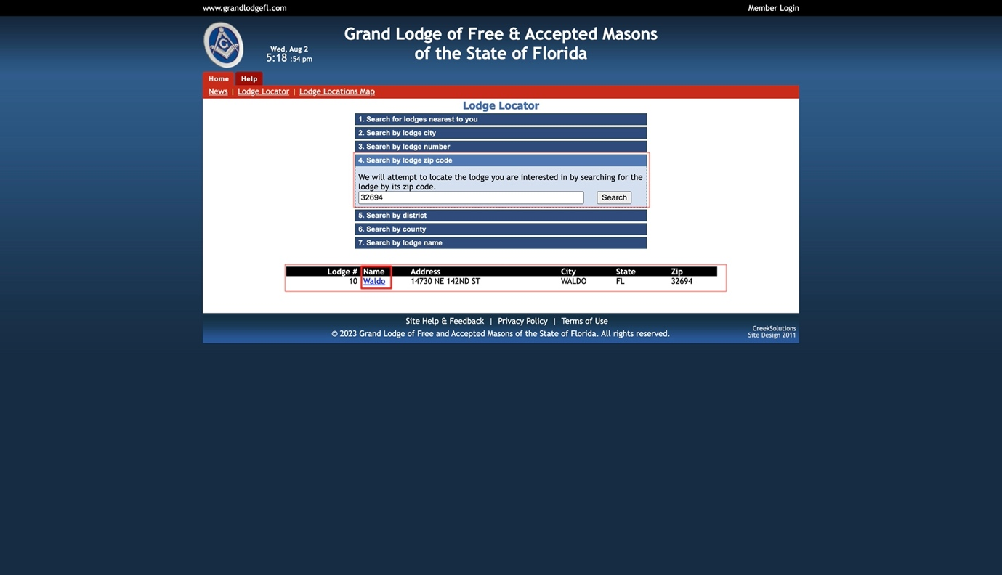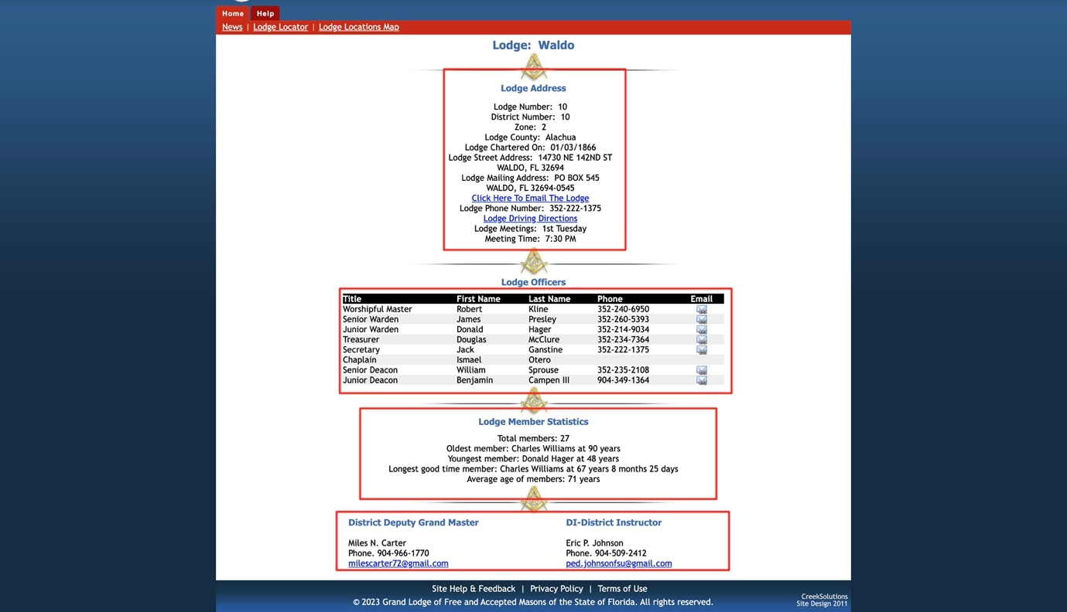  
  
NOTE: The deliverable consists of a script and the data format will be CSV.